 

***Title Name***

***Educational Organisation Using ServiceNow***

**Table of Contents**

1. Problem Statement
2. Project Overview
3. Objectives
4. ServiceNow Developer Setup
5. Form Design
6. Number Maintenance
7. Process Flow
8. Client Scripts
9. Results

10.Conclusion

**Problem Statement**

Educational institutions handle a wide range of activities including student admissions, faculty requests, administrative tasks, and IT support. Traditionally, these processes are managed manually through paperwork, emails, or disconnected systems. This leads to several challenges such as:

* Delays in approvals and request processing.
* Lack of centralized data storage and tracking.
* Miscommunication between students, faculty, and administrators.
* Difficulty in monitoring performance and generating reports.
* Inefficient handling of repetitive tasks and service requests.

As a result, both students and staff face difficulties in accessing services efficiently, and administrators struggle with maintaining transparency and accountability

**Project Overview**

The project **“Educational Organisation Using ServiceNow”** is aimed at developing a digital solution for managing the various operations of an educational institution by leveraging the ServiceNow platform. Educational institutions typically face challenges in handling student records, faculty requests, administrative processes, and IT service management. Manual processes often lead to inefficiencies, delays, and lack of transparency.

This project addresses these challenges by implementing a **centralized ServiceNow solution** that automates workflows, streamlines service requests, and ensures smooth communication between students, faculty, and administration. The system provides a structured platform where:

* **Students** can raise requests related to admissions, course registrations, library access, and technical support.
* **Faculty members** can manage academic-related requests, track approvals, and access resources seamlessly.
* **Administrators** can monitor institutional processes, assign tasks, track progress, and generate reports for decision-making.

By utilizing ServiceNow’s capabilities like **Flow Designer, Service Catlog, Incident Management, and Reporting**, the solution enhances the overall efficiency of the educational organisation. It reduces manual intervention, ensures quick resolution of issues, and provides transparency across all levels of the institution.

The project also demonstrates how **low-code/no-code tools in ServiceNow** can be applied beyond traditional IT service management, extending into the education domain to modernize processes.

**Objectives**

The main objectives of the project are:

1. **Automation of Processes** – To reduce manual work and human errors by automating student, faculty, and administrative workflows.
2. **Centralized Platform** – To create a single ServiceNow-based platform that connects students, faculty, and administrators.
3. **Improved User Experience** – To provide a self-service portal for easy request submission and tracking.
4. **Transparency & Accountability** – To ensure all requests and processes are trackable, reducing delays and miscommunication.
5. **Data-Driven Insights** – To generate reports and dashboards that help administrators make informed decisions.
6. **Scalability** – To build a solution that can be adapted to different educational institutions and expanded with additional modules if needed.

**4. ServiceNow Developer Setup**

To build and test applications in ServiceNow, you need to set up a **developer environment**. The steps are as follows:

1. Visit the Service now developer website (<https://developer.servicenow.com/dev.do>).

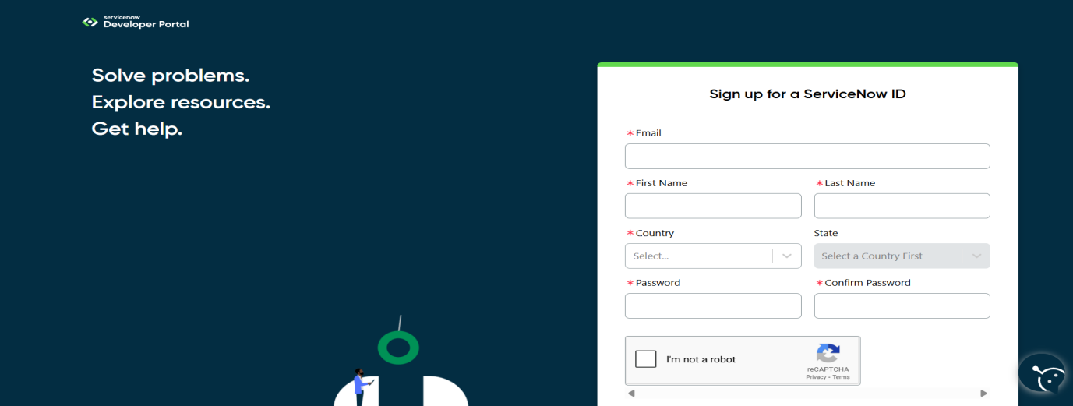

1. Sign up for a free developer account by providing the required details.
2. Once registered, you’ll receive a verification email. Confirm your account through the email link.
3. After successful verification, your Developer Portal Dashboard will be available.
4. From here, click on “Start Building” to access options for requesting a Personal Developer Instance (PDI) or to explore tools like App Engine Studio.

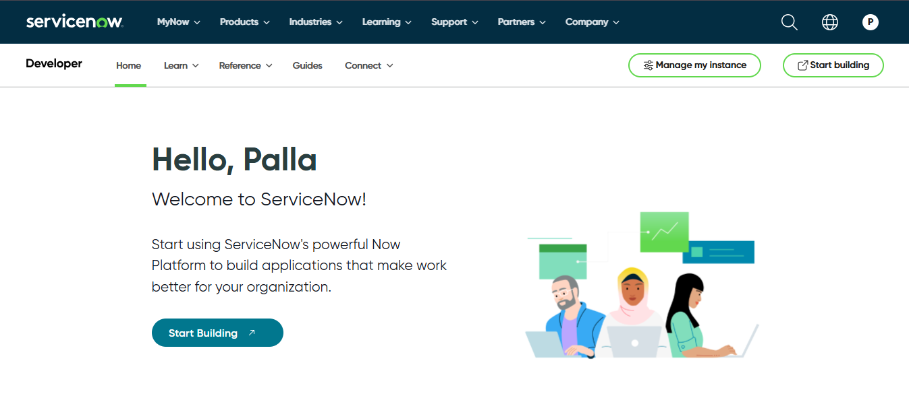

1. Using the profile icon in the top-right corner, you can manage your account, request new instances, and view your developer profile.

This setup provides a **dedicated sandbox environment** where you can safely practice, design, and implement ServiceNow applications without affecting live systems

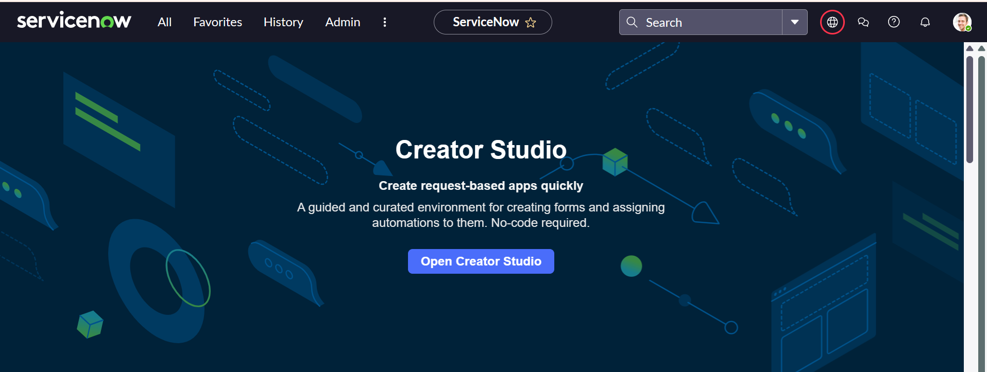

**Creating a Update Set:**

1. From the left navigation menu, click on All search for **Update set**

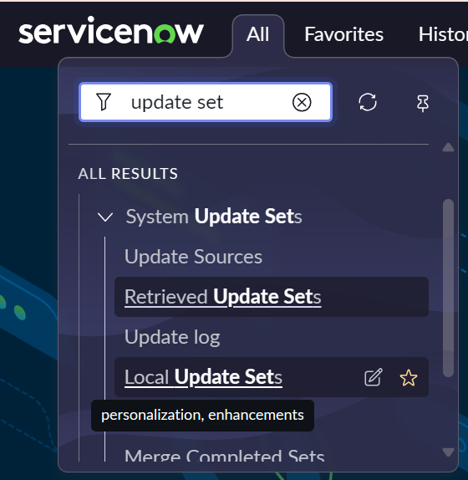

1. Under **System Update Sets**, select **Local** **Update Sets**.
2. Click **New** to add a New Update Set.
3. Enter the necessary information (Name as Educational Orgaanisation Using ServiceNow).
4. Click **Submit** to save the record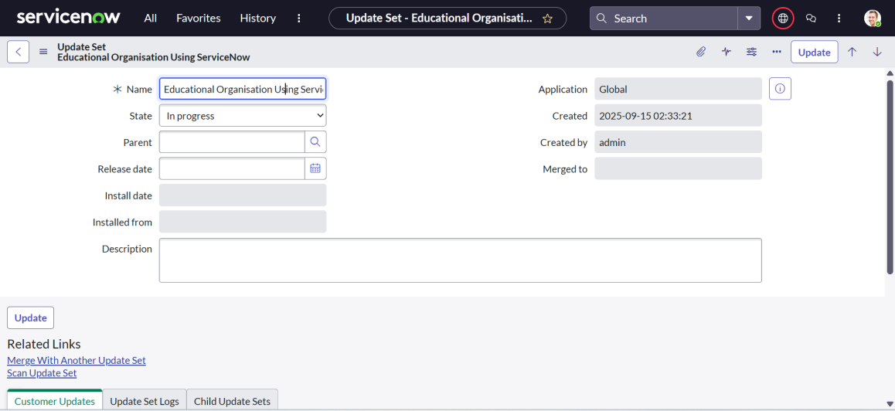

### **Creating a Table**

1. In the navigation panel,click on all and search for **Tables**.
2. Under **System Definition**, click on **Tables.**

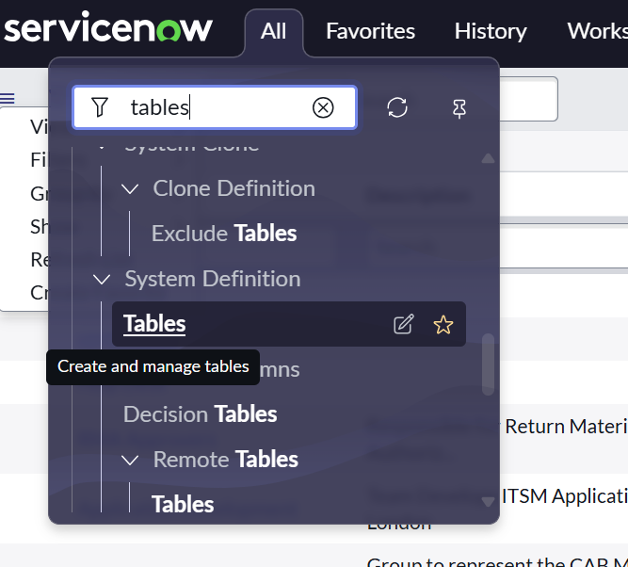

1. Click **New** to create a new table.
2. Provide the table details:
   * **Label** →Salesforce
   * Click on Name it will Automatically generate Api name.
   * Create columns as Student Name, Admin Number, Mother Name, Admin Date, Father Name, Father cell, Mother Cell, Grade Double Click on Column label and Enter the Column labels and click on the tick mark

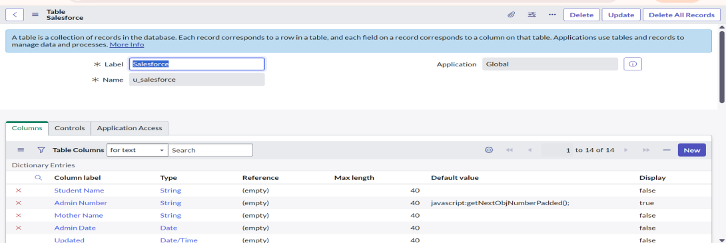

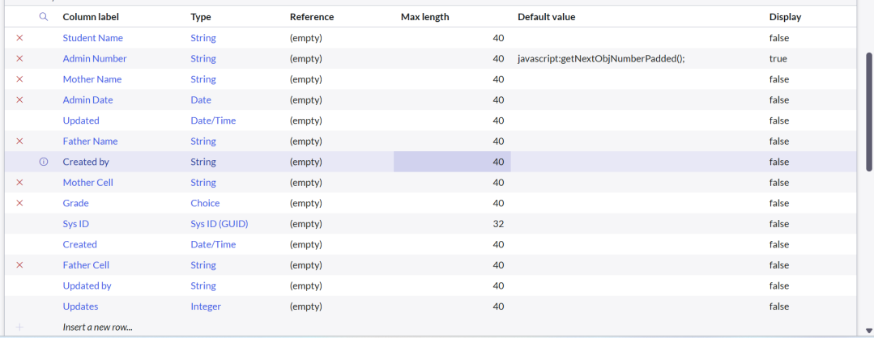

* Click on controls and Enable Extensible.

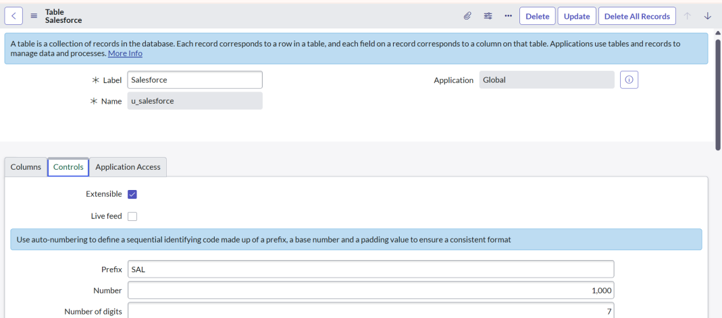

* Click on “Admin Number” column, In Related Links Click on Advanced View in that click on Default View (Enable Use dynamic default) and select Get Next Padded Number in Dynamic default value and Update
* Click on “Grade” Column
* Click on Choices and give Label, Value and Sequence as given below.

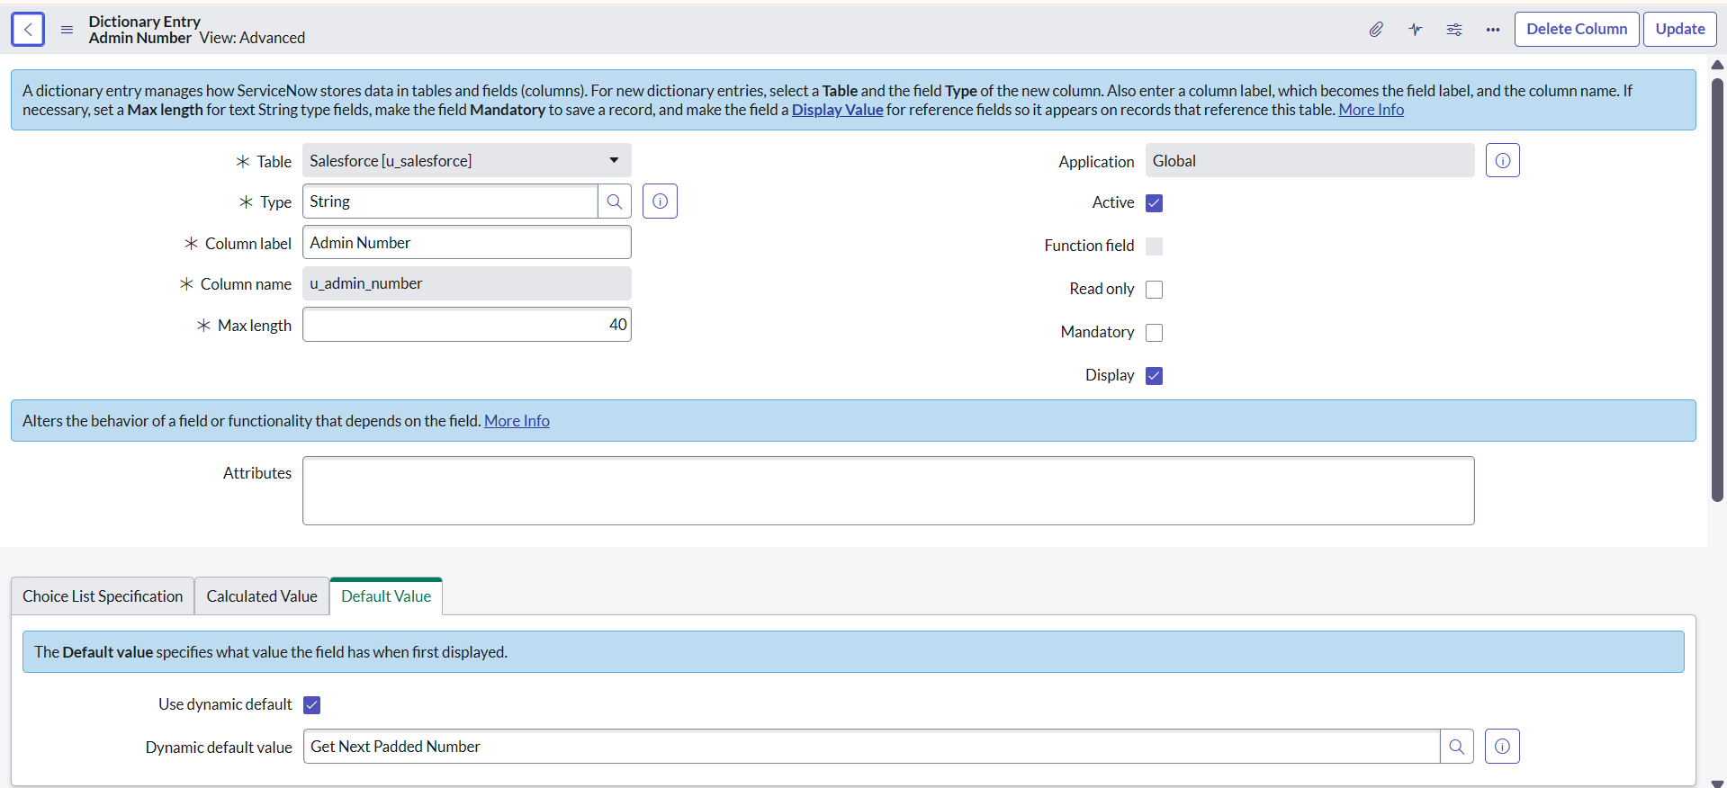

* Same as do for grade Coloumn,
* Click on the grade in Coloumn of salesforce table and insert the given values
* Once done, then click on the update on the right top

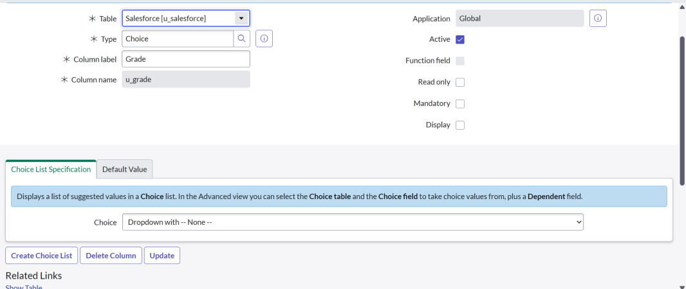

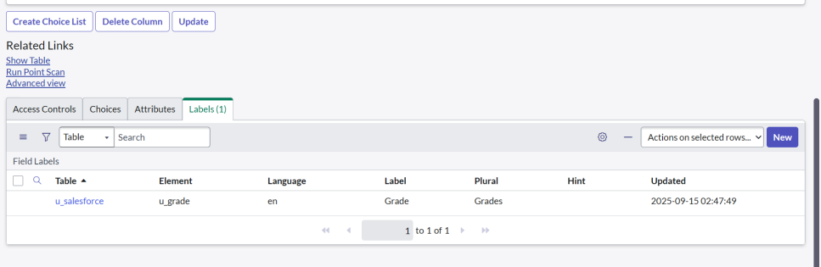

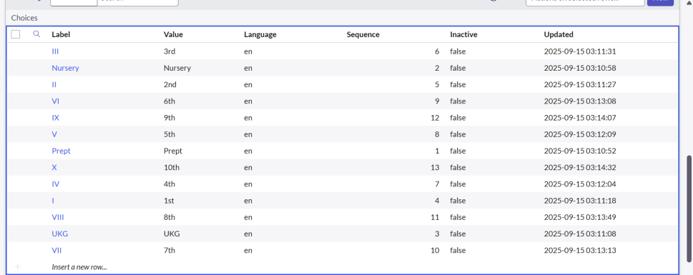

**Creating Admission Table**

1. In the navigation panel, click on all and search for **Tables**.
2. Under **System Definition**, click on **Tables.**

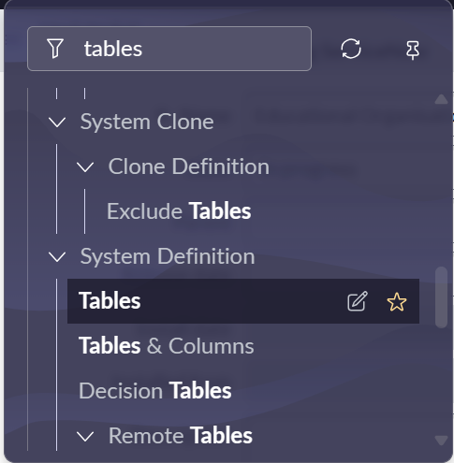

1. Click **New** to create a new table.
2. Provide the table details:
   * **Label** → Admission Table with Columns given.
3. Select Extends Table as Salesforce
4. Select Add module to menu as Salesforce, And Fill the related coloumn label, type, Default values as given  
    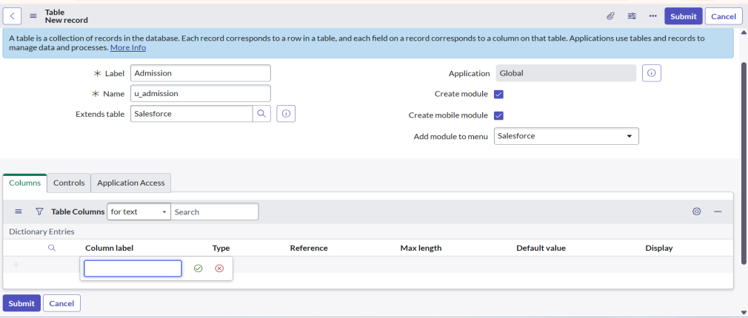

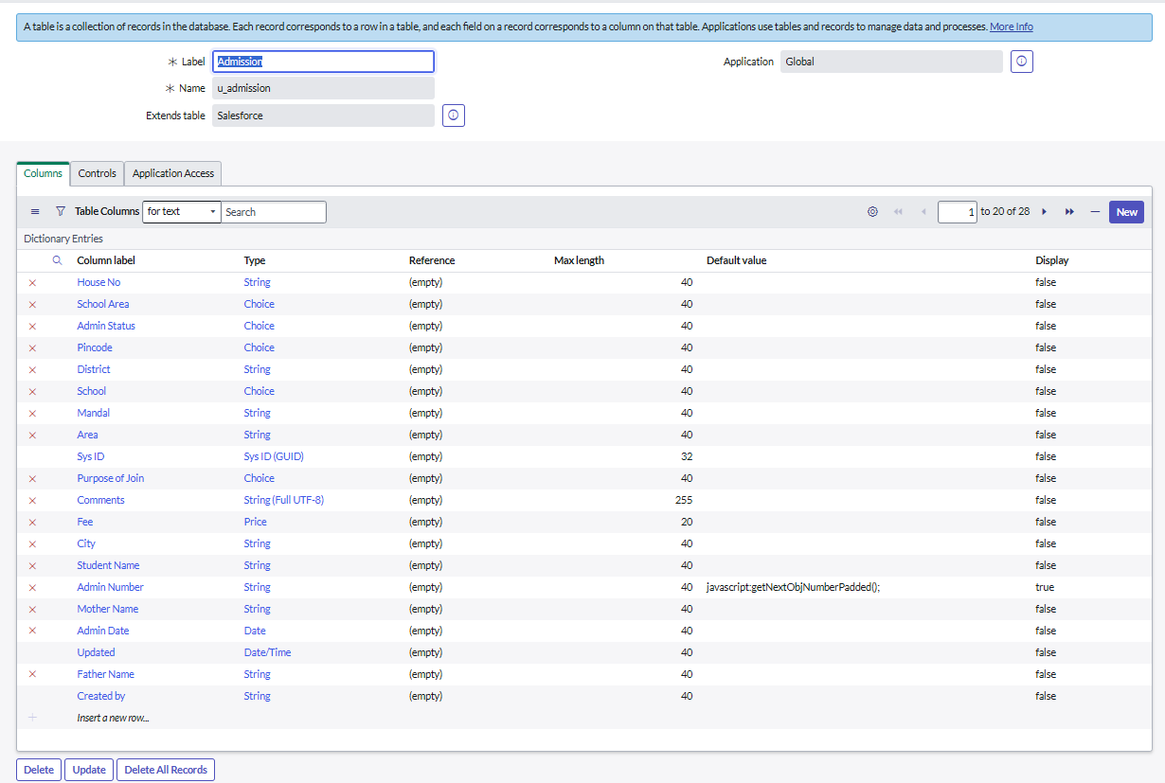

* After creating all the fields click on save on the toggle bar
* Click on the Admin Status and Create choice for Admin Status

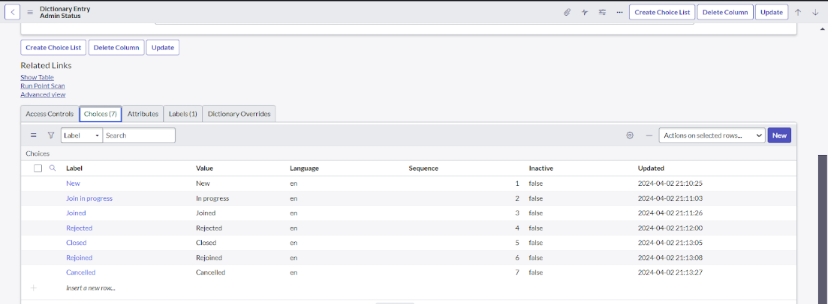

* Same as go to admission table
* Click on the Pincode and Create choice for Pincode

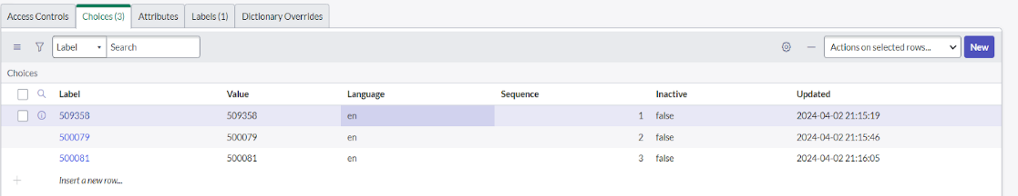

* Same as Create choice for Purpose of Join

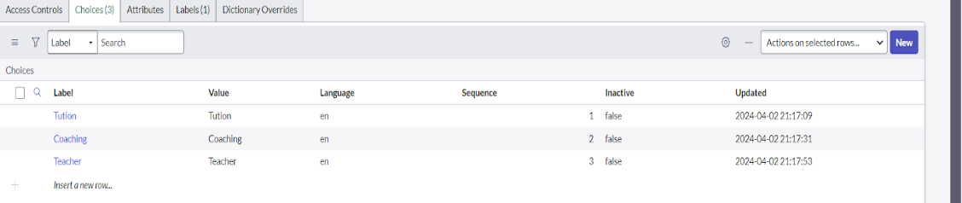

* Same as Create choice for School

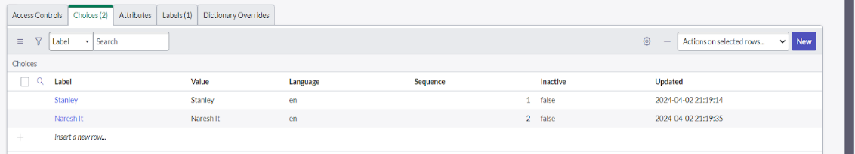

* Create choice for School Area

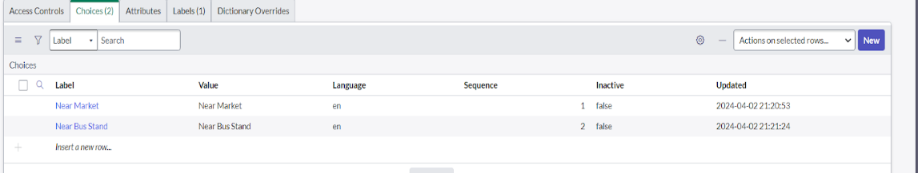

**Creating Student Progress Table**

1. In the navigation panel, click on all and search for **Tables**.
2. Under **System Definition**, click on **Tables.**
3. Create a label as Student Progress Table with Columns given.
4. Select Add module to menu as Salesforce
5. After Creating student table, Create and add the column label, type, reference as given

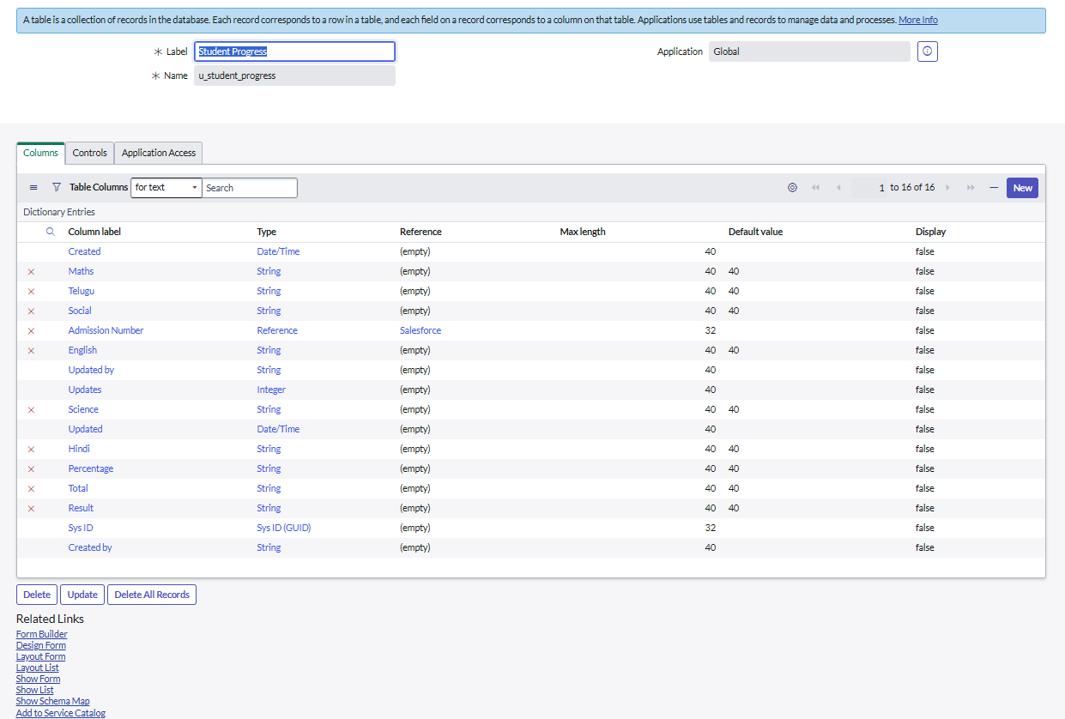

Configuring Table form for Student Progress Table

* Once it was done, In the Student Progress Table Page, Click on Layout form

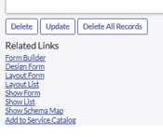

* It will show like this, Click on Admission Number [+] Select Admission Number fields in Available side and send it to selected side
* Once done Click on save

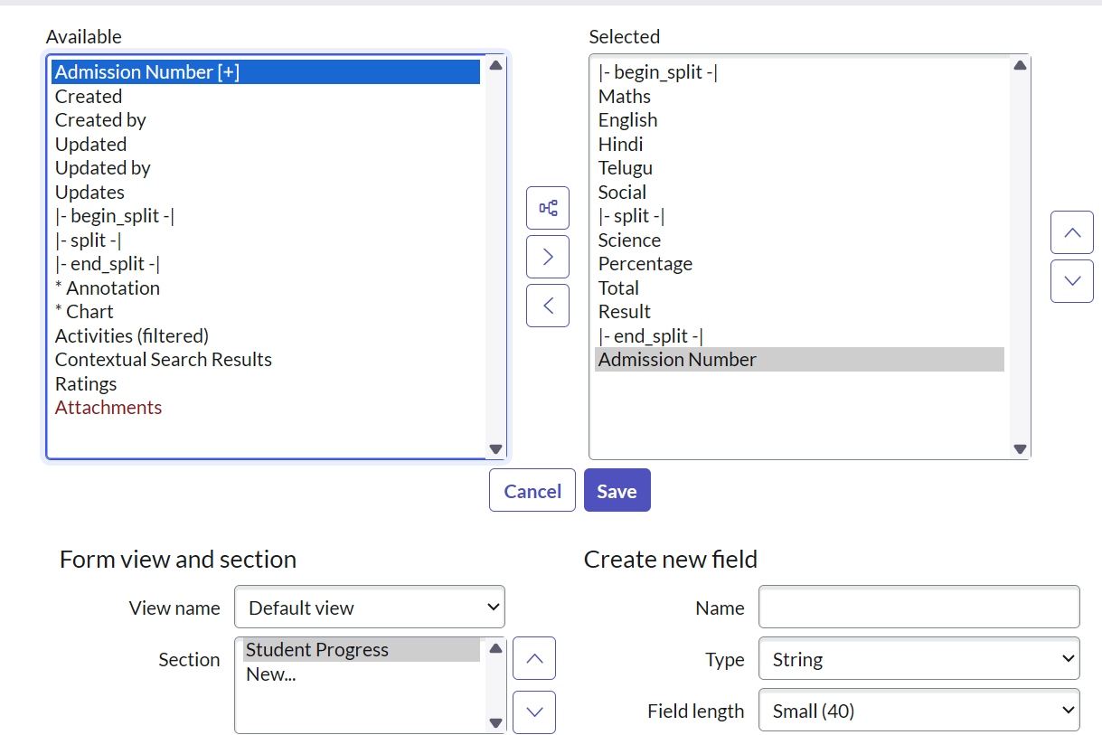

**Creating Form Design for Salesforce Table**

* In the navigation panel, click on all and search for **Tables**.
* Under **System Definition**, click on **Tables.**



* In Label Search for Salesforce and open .

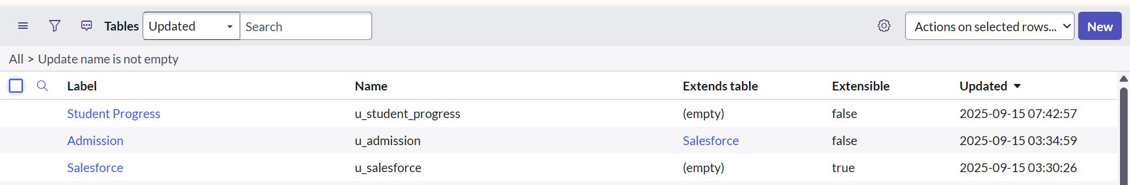

* After opening on the salesforce table
* Right Click on top Toggle

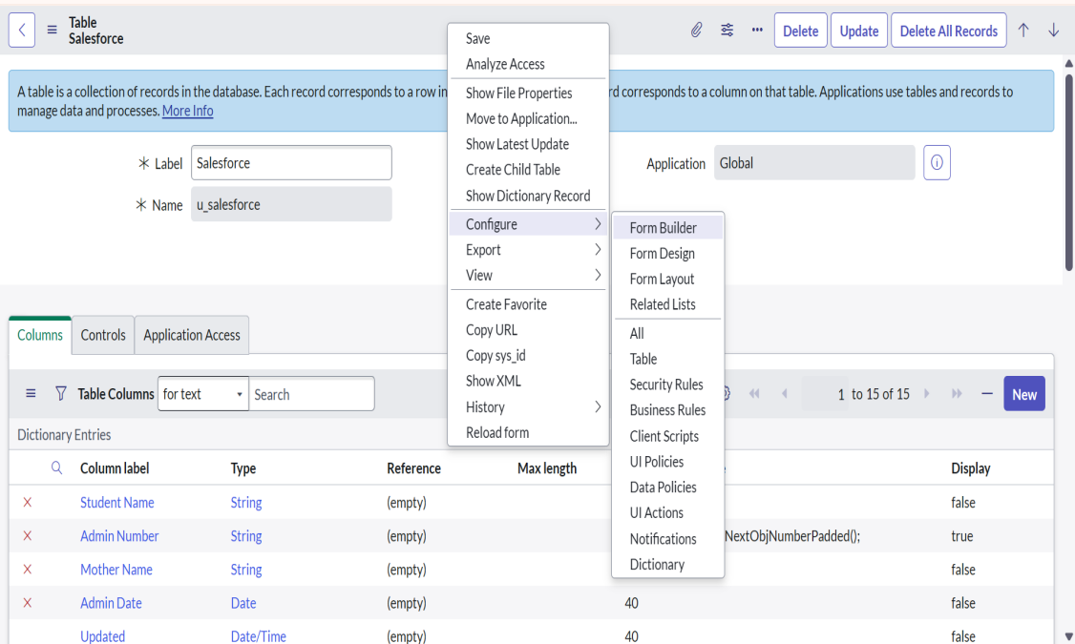

* select Configure click a Form Design.

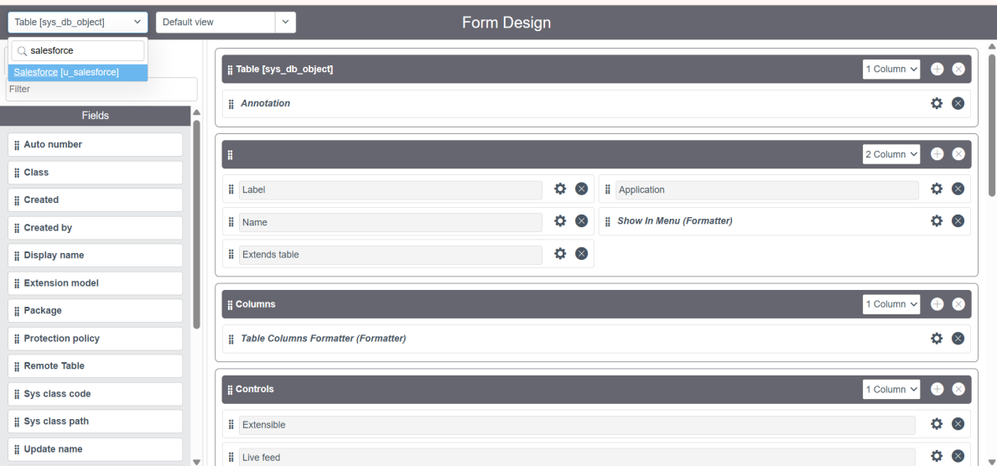

* Once the page opens ,change the table name as salesforce table and In drop down select Salesforce(u_salesforce).
* Drag and drop the fields to the left side as given
* Once done click on save

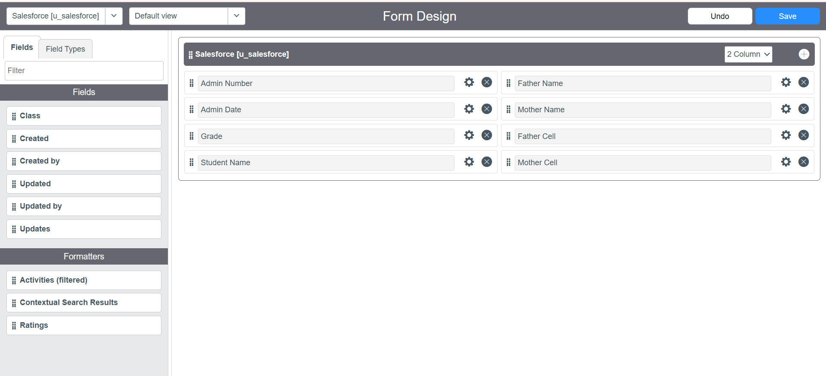

**Creating Form Design for Admission Table**

* Repeat the same process for Admission Table
* Drag and drop the fields to the left side as given
* Once done click on save.

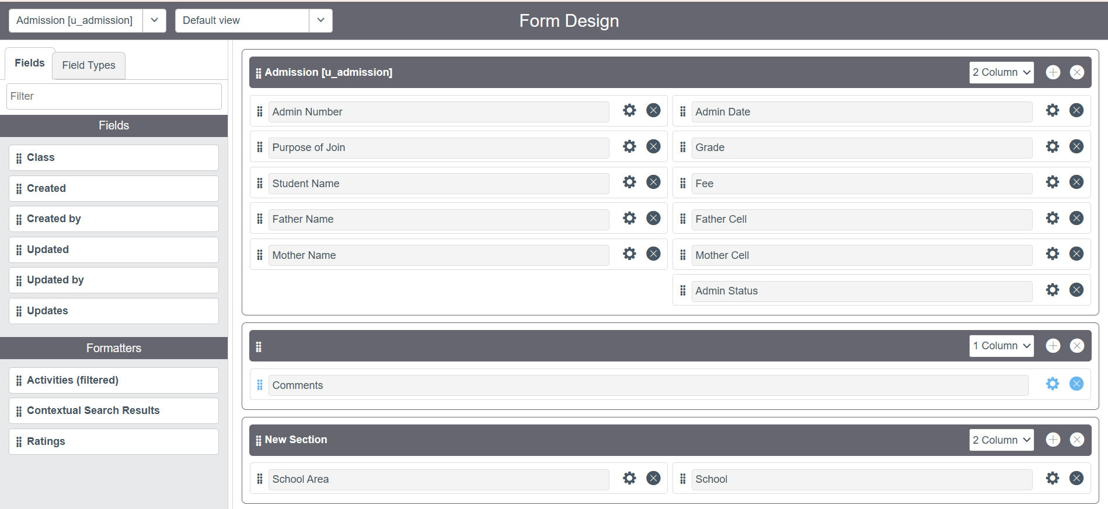

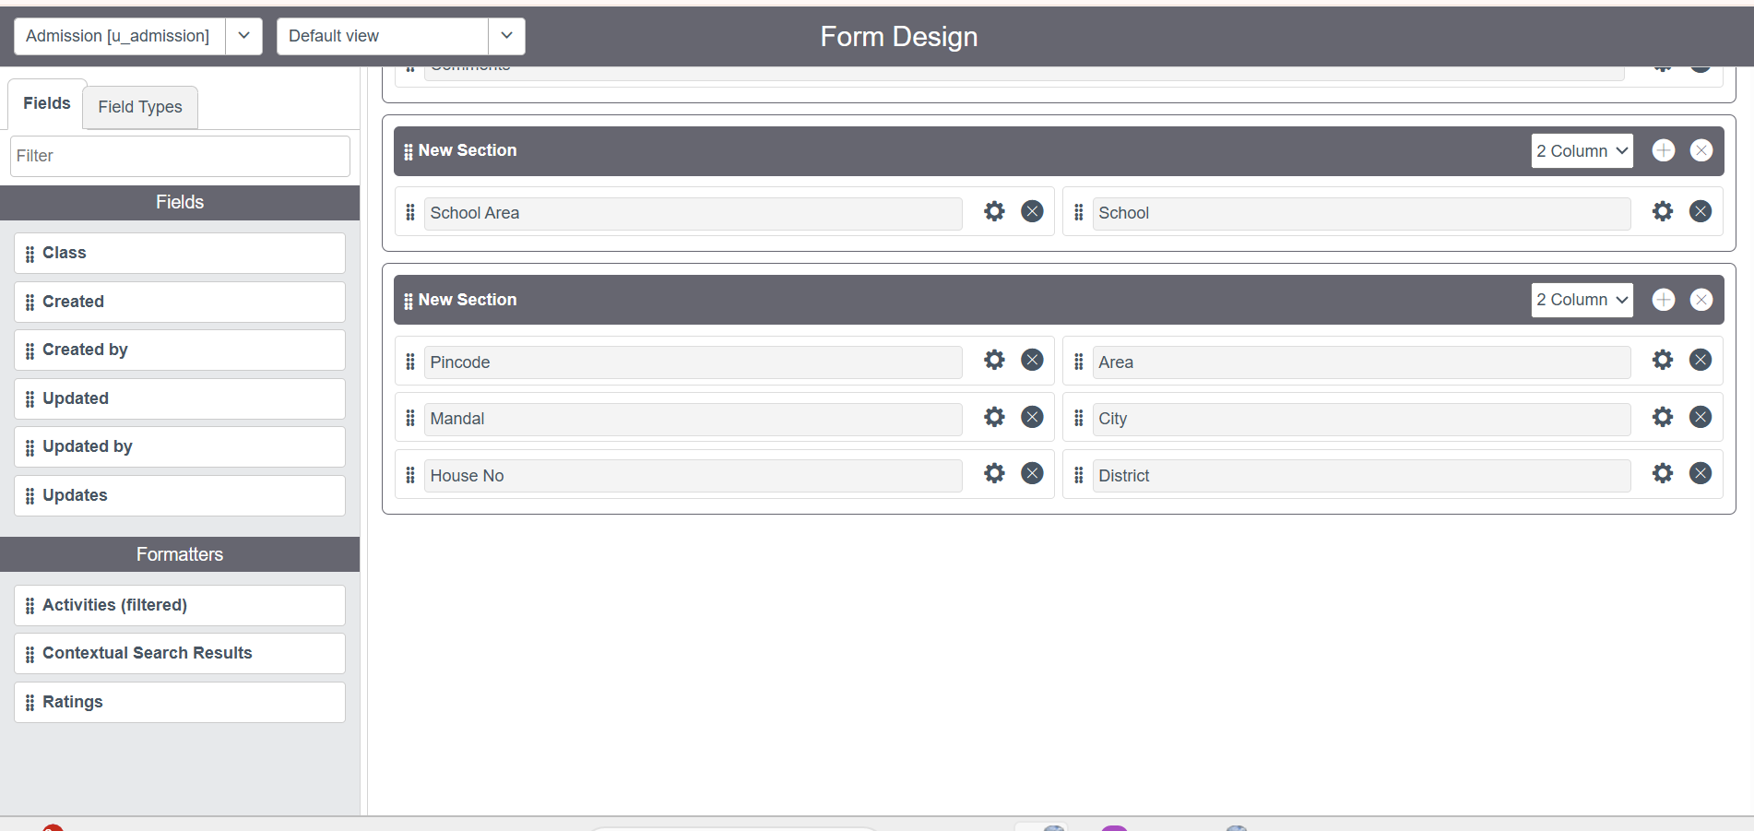

**Creating Form Design for Student progress Table**

* Repeat the same process for Student Progress Table
* Select Table Name as Student Progress(u_ student_progress)
* Drag and drop the fields to the left side as given
* Once done click on save

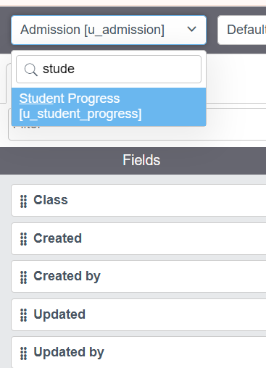

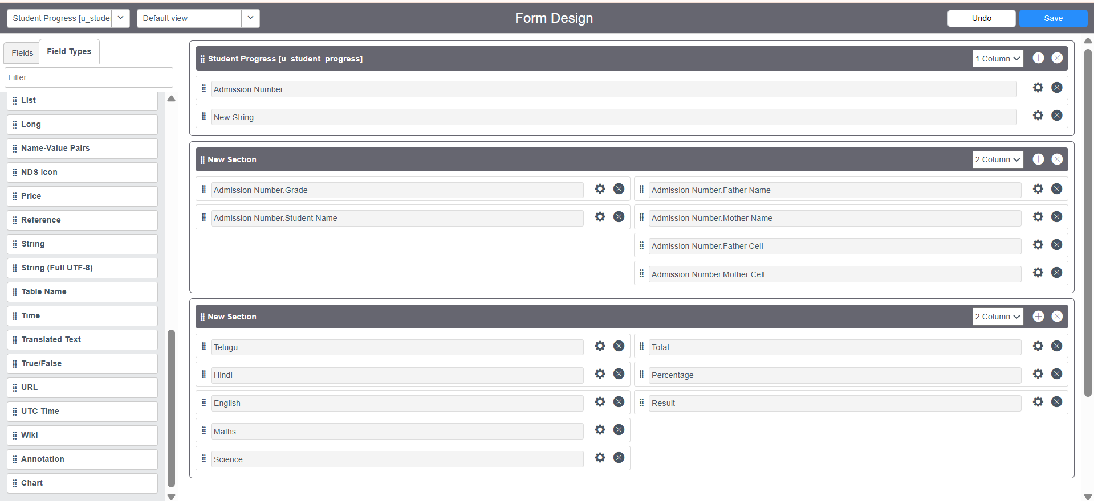

**Creating Number Maintenance for Admin Number**

* In the navigation panel,click on all and search for **Number Maintenance**.
* Under **System Definition**, click on **Number Maintenance.**
* Click **New** to create

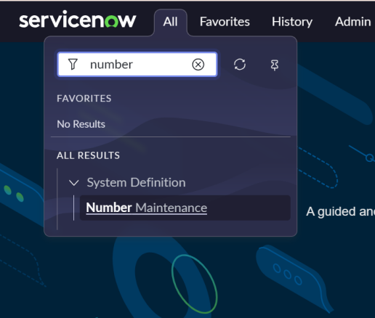

* Give table name as salesforce
* Give prefix as SAL
* Click on save  
   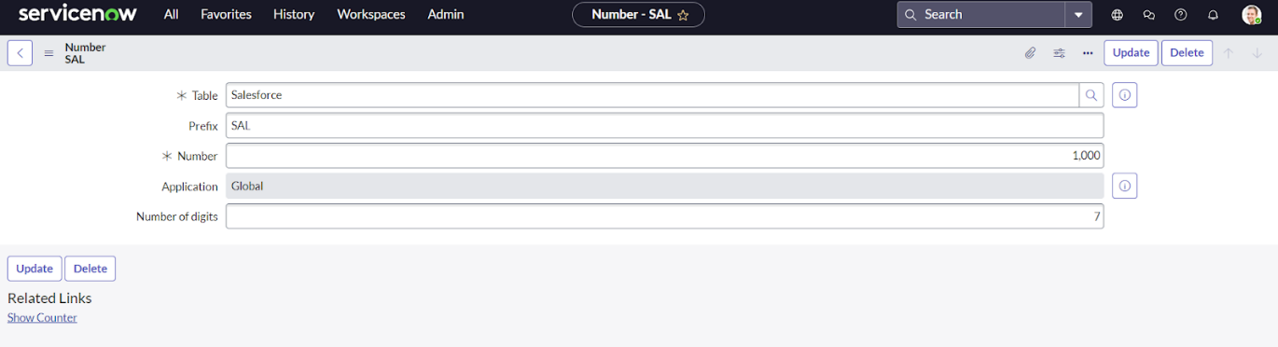

### **Creating Process Flow for Admission Table**

* In the navigation panel, click on all and search for **Process Flow**.
* Under **System UI**, click on **Process Flow.**
* Click **New** to create
* Give table name as Admission[u_admission]
* Set Name and Label as New and Order is 1
* Once gave the details clisck on save

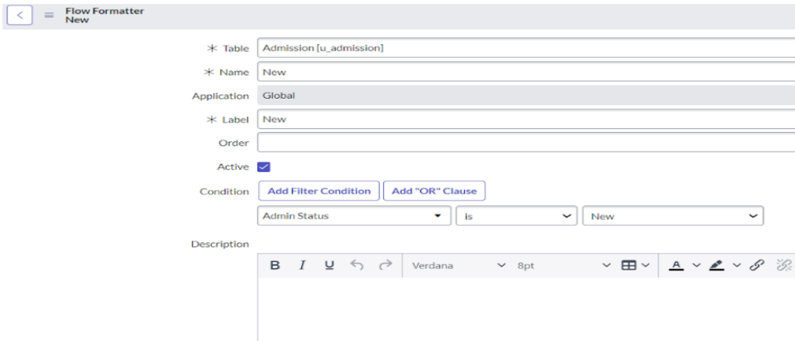

* Repeat the same process for In Progress and click on insert and stay

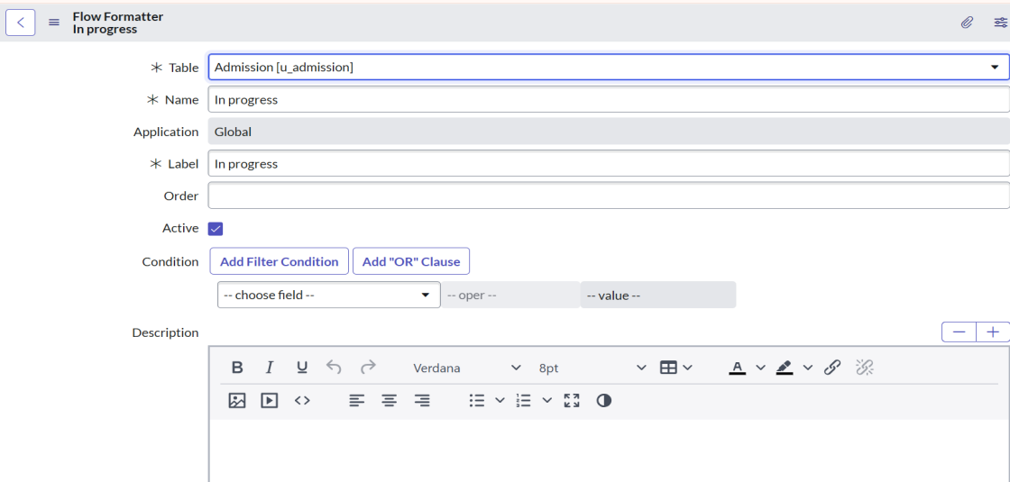

* As same above repeat the same process and Replace the Name and Label in order and click on Insert on stay.
* Joined , Rejected , Rejoined , Closed , Cancelled

### **Creating “Auto populate” Client Scripts for Admission Table**

1. In the navigation panel, click on all and search for **Client Scripts**.
2. Under **System Definition**, click on **Client Scripts.**

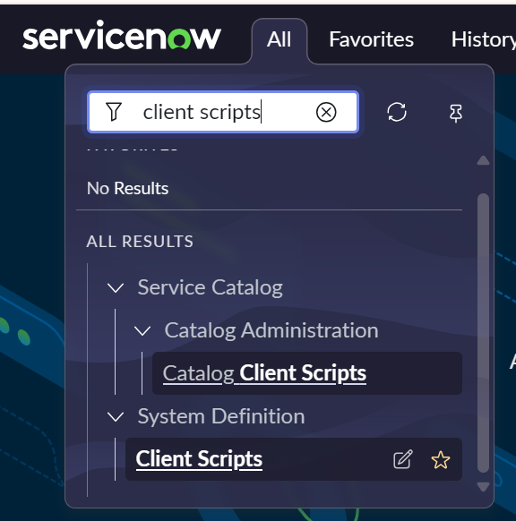

* Click **New** to create a new table.
* Provide the table details:
* Give name as auto populate and table name as admission table, mobile/service portal as UI Type and field name as Admin Number
* Write the Code , Enable Isolate script and Save

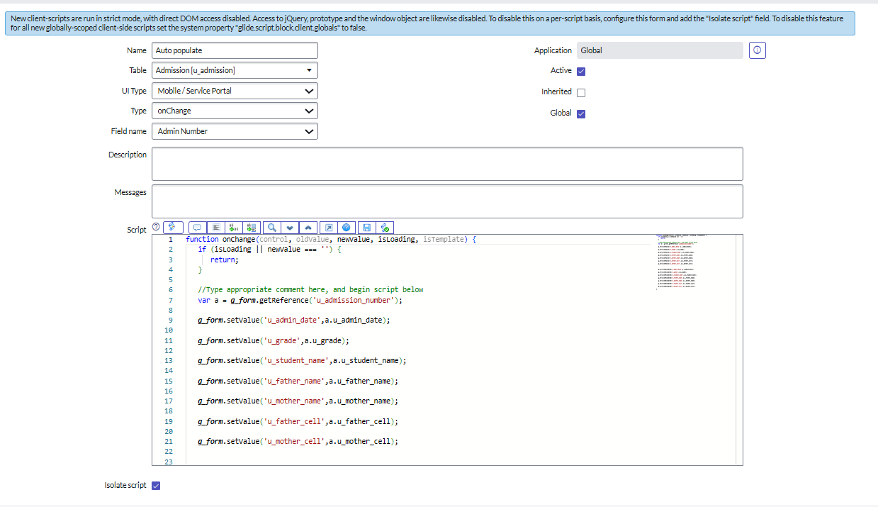

* Repeat the same process for Pincode Update and fill the related information
* Write the Code , Enable Isolate script and Save

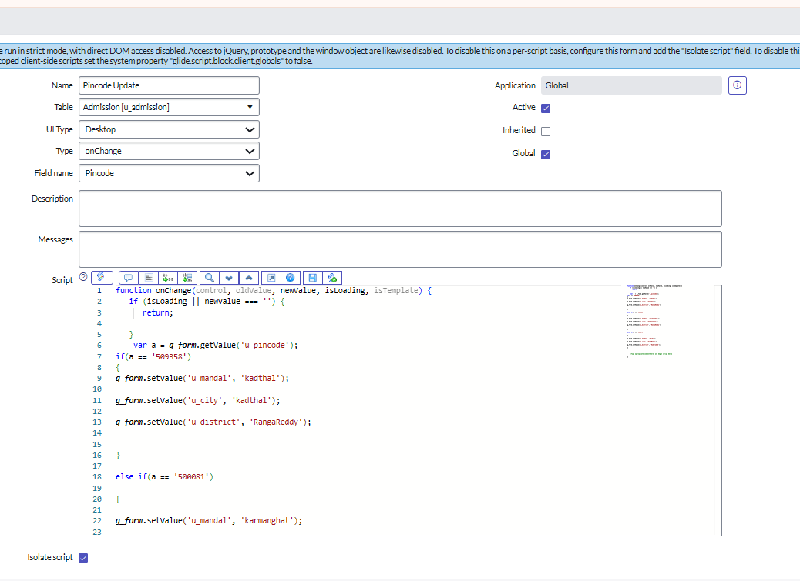

* Repeat the same process for Disable Fields and fill the related information
* Write the Code, Enable Isolate script and Save

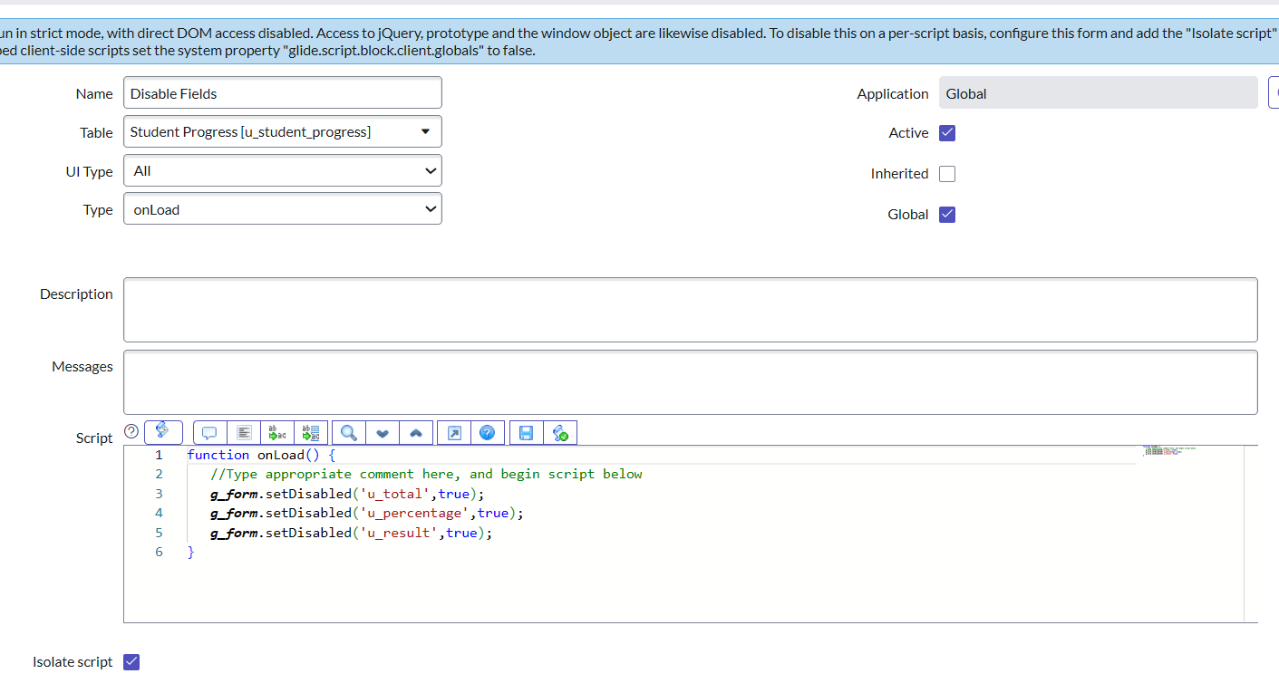

* Repeat the same process for Total Update and fill the related information
* Write the Code, Enable Isolate script and Save

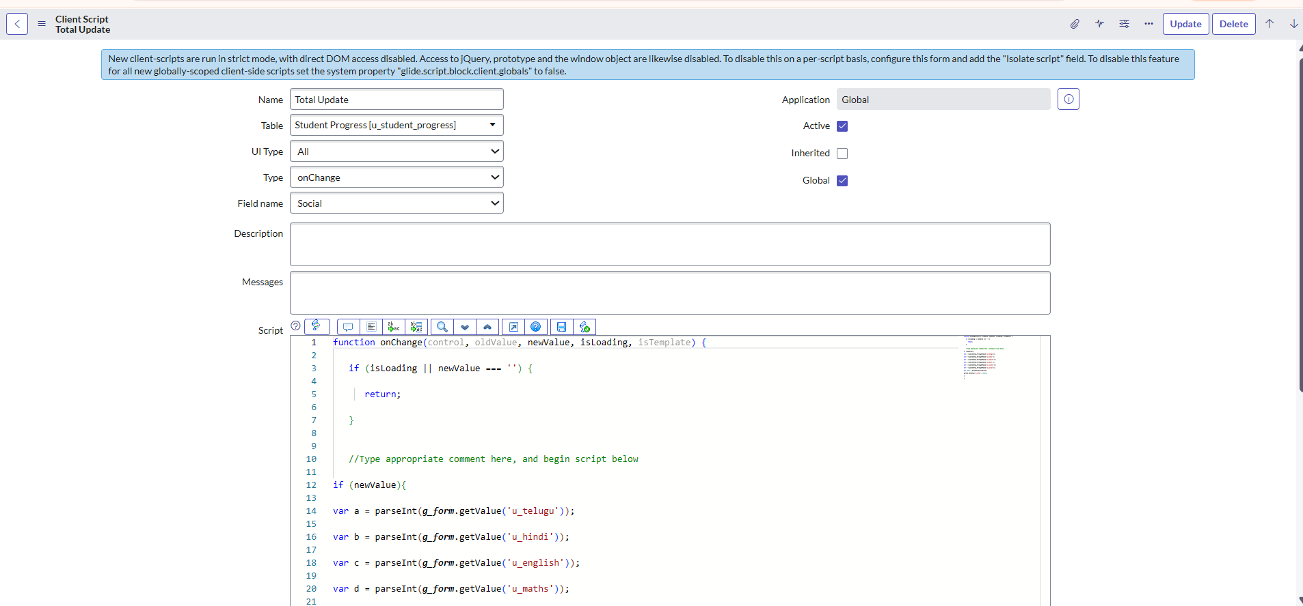

* Repeat the same process for Result and fill the related information
* Write the Code, Enable Isolate script and Save

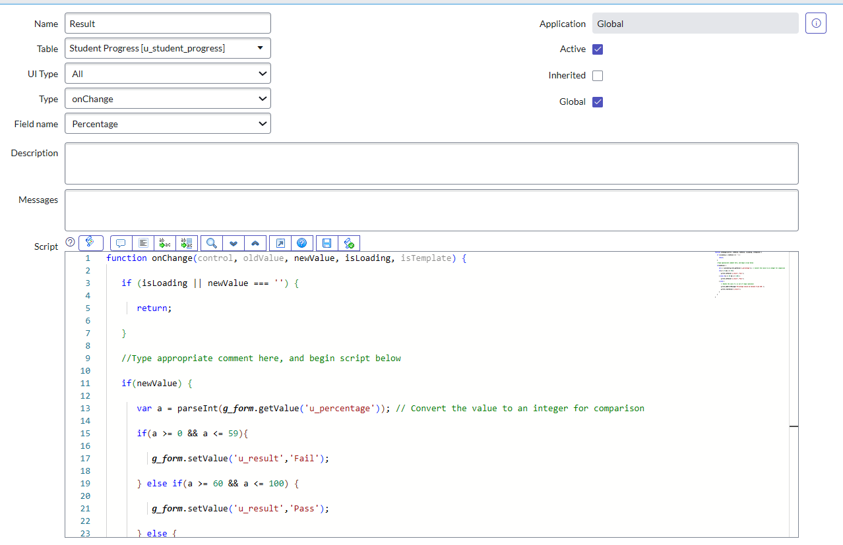

* Repeat the same process for Percentage and fill the related information
* Write the Code, Enable Isolate script and Save

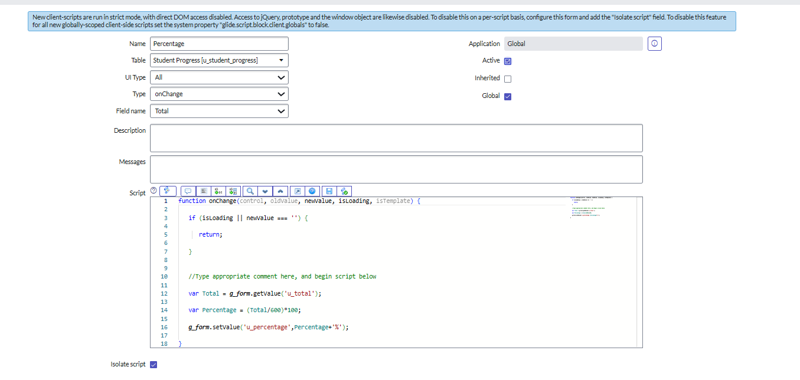

**Results**

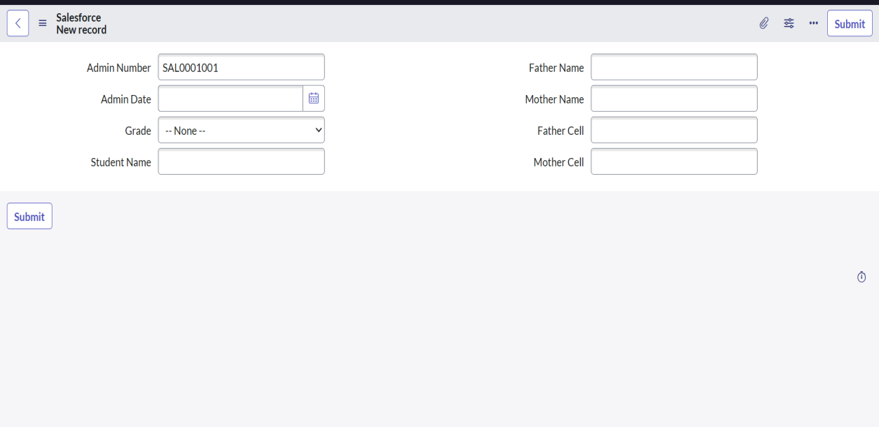

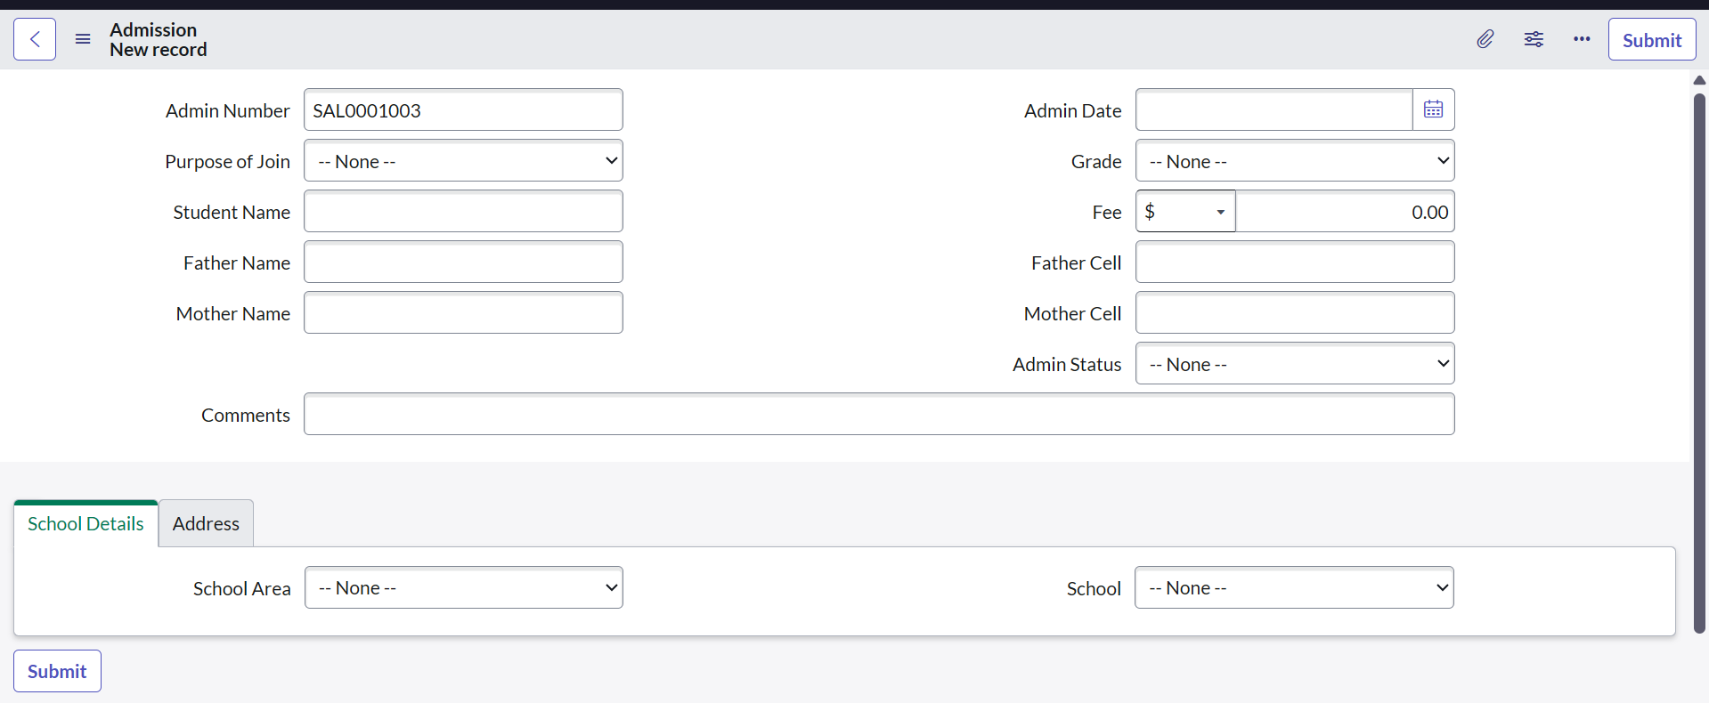

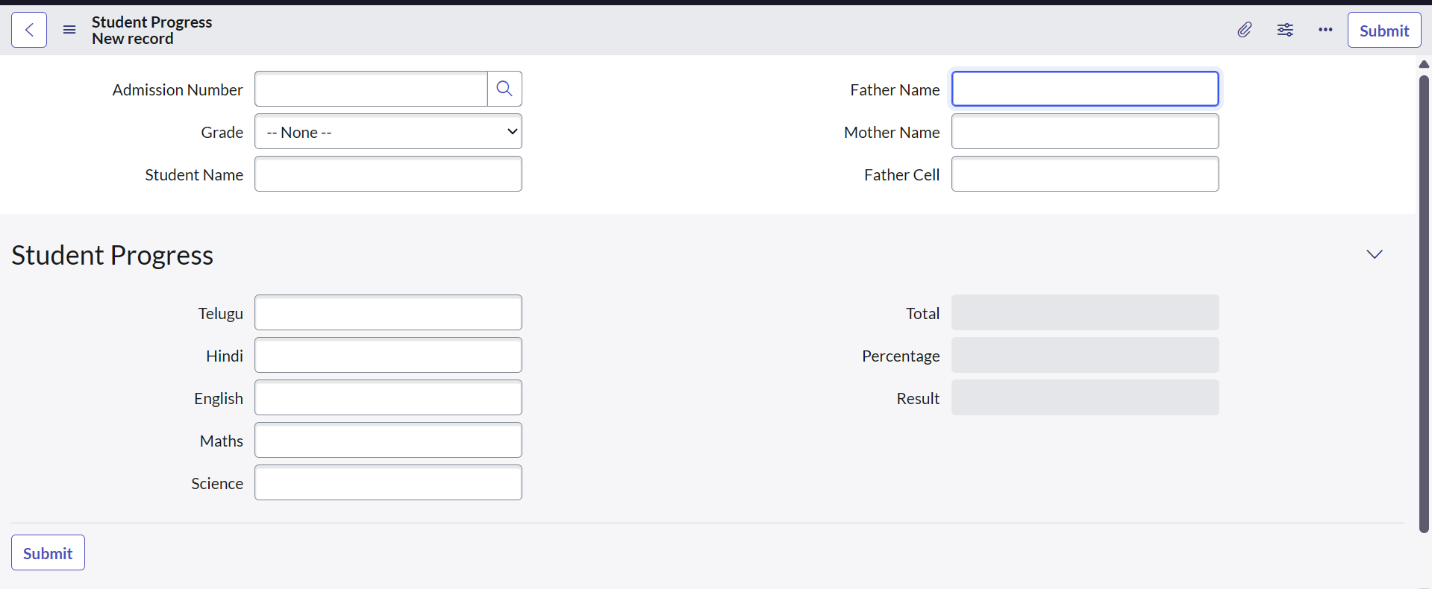

**Conclusion**

The project *“Educational Organisation Using ServiceNow”* highlights how ServiceNow can streamline processes in the education sector by automating workflows, managing requests, and improving communication between students, faculty, and administrators. It demonstrates that ServiceNow is not only useful for IT industries but also has strong potential in non-IT domains like education, where efficiency, transparency, and user satisfaction are crucial.

* Improved service delivery through workflow automation.
* Centralized platform for handling student and faculty requests.
* Enhanced transparency and accountability in administrative tasks.
* Self-service portals and knowledge base for quick query resolution.
* Better decision-making using dashboards and reports.

In this Summary, The project *“Educational Organisation Using ServiceNow”* streamlines student, faculty, and administrative processes by automating workflows, improving service delivery, and creating a more efficient digital environment for education.

GitHub Link: https://github.com/Bhumikapalla/Educational-Organisation-Using-ServiceNow.git